Лабораторная работа №4
по курсу
«Параллельные и распределенные вычисления»

Ада. Защищенный модуль

Выполнил
студент группы ИВ-71
Тищенко Денис
Техническое задание
A = sort( B + C * (ME * MK) )
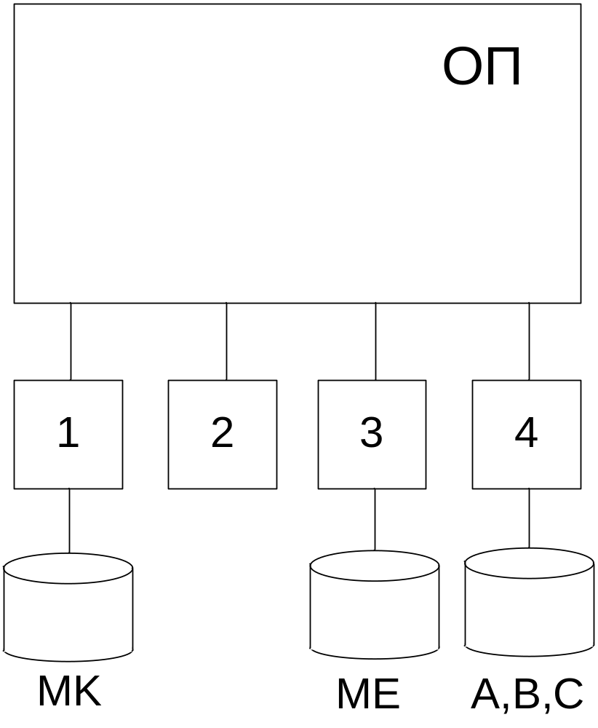
Этап 1. Построение параллельного алгоритма
Вычисление данного матричного уравнения можно разбить на этапы:
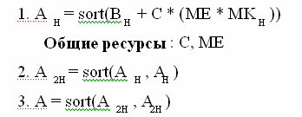
Этап 2. Разработка алгоритмов процессов (задач)
№ Т1 ТС/КУ

1. Ввод MK
2. Сигнал задачам T2, T3, T4 о вводе MK S11
3. Ждать ввода в T3, T4 W31,W41
4. Копирование C КУ
5. Копирование МE КУ
7. Сигнал T3 об окончании счета S21

№ Т2 ТС/КУ

1. Ждать ввода в T3, T4 W32,W42
2. Копирование C КУ
3. Копирование МE КУ
5. Сигнал T4 об окончании счета S12
№ Т3 ТС/КУ

1. Ввод ME
2. Сигнал задачам T1, T2, T4 о вводе ME S13
3. Ждать ввода в T1, T4 W13,W43
4. Копирование C КУ
5. Копирование МE КУ
7. Ждать окончания счета в T1 W132
9. Сигнал T4 об окончании счета S23

№ Т4 ТС/КУ
1. Ввод B,C
2. Сигнал задачам T1, T2, T3 о вводе B,C S14
3. Ждать ввода в T1, T3 W14,W34
4. Копирование C КУ
5. Копирование МE КУ
7. Ждать окончания счета в T2 W24
9. Ждать окончания слияния в T3 W342
11. Вывод А
Этап 3. Разработка структурной схемы взаимодействия процессов

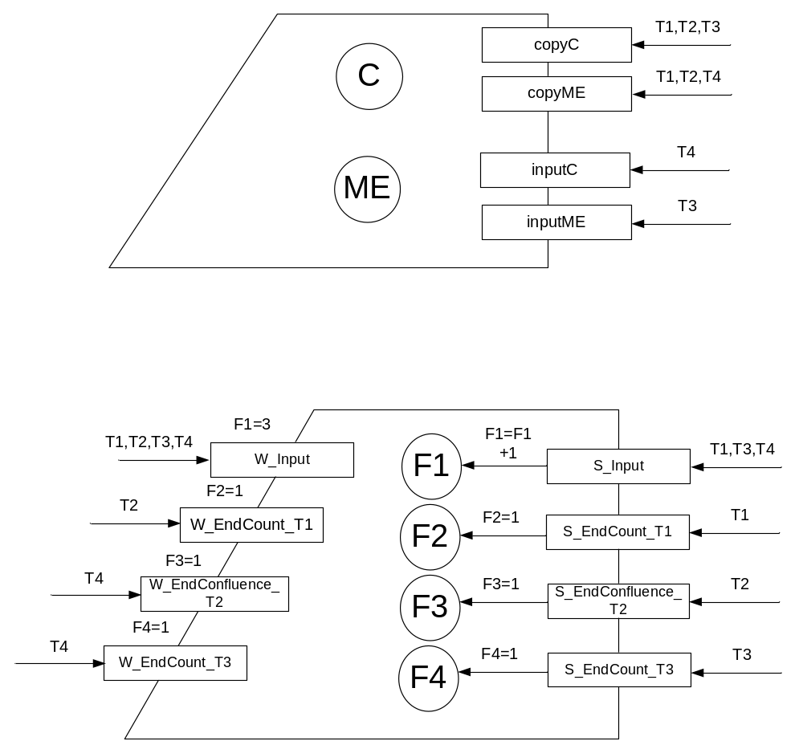
Этап 4. Разработка программы
Source file: ..\..\..\..\..\Документы\Рабочие\6семестр\ПРО\про_лаб4\main Sun Apr 18 18:46:54 2010

1 --------------------------------------------------
2 --- Parallel and distributed calculations
3 --- Laboratory Work # 4
4 --- Ada. Protected Units
5 ---
6 --- A = sort(B+C(ME*MK))
7 ---
8 --- Tyschenko Denis
9 --- IO-71
10 ---
11 --- 16 April 2010
12 --------------------------------------------------
13
14 with Ada.Text_IO; use Ada.Text_IO;
15 with Ada.Integer_Text_IO; use Ada.Integer_Text_IO;
16 procedure main is
17 N : integer := 16;
18 p : integer := 4;
19 H : integer := N/p;
20
21
22 type Vector is array (1..N) of integer;
23 type Matrix is array (1..N) of Vector;
24
25 A,B: Vector;
26 mK : Matrix;
27
28
29
30 protected Exclusion is
31 function CopyME return Matrix;
32 function CopyC return vector;
33 procedure InputME(Me1: in Matrix);
34 procedure InputC(Ch: in Vector);
35
36 private
37 ME: Matrix;
38 C: Vector;
39
40 end Exclusion;
41
42 protected body Exclusion is
43
44 function CopyC return Vector is
45 begin
46 return C;
47 end CopyC;
48
49 function CopyME return Matrix is
50 begin
51 return ME;
52 end CopyME;
53
54 procedure InputME (me1: in matrix) is
55 begin
56 Me:=me1;
57 end InputME;
58
59 procedure InputC (Ch: in Vector) is
60 begin
61 for i in 1..N loop
62 c(i):=Ch(i);
63
64 end loop;
65 end InputC;
66
67 end Exclusion;
68
69
70 protected Synhro is
71 procedure S_Input;
72 procedure S_EndCount_T1;
73 procedure S_EndConfluence_T2;
74 procedure S_End_Count_T3;
75
76 entry W_Input;
77 entry W_EndCount_T1;
78 entry W_EndConfluence_T2;
79 entry W_EndCount_T3;
80
81 private
82 F1:integer:=0;
83 F2:integer:=0;
84 F3:integer:=0;
85 F4:integer:=0;
86 end Synhro;
87
88 protected body Synhro is
89
90 procedure S_Input is
91 begin
92 F1:=F1+1;
93 end S_Input;
94
95 procedure S_EndCount_T1 is
96 begin
97 F2:=1;
98 end S_EndCount_T1;
99
100 procedure S_EndConfluence_T2 is
101 begin
102 F3:=1;
103 end S_EndConfluence_T2;
104
105 procedure S_End_Count_T3 is
106 begin
107 F4:=1;
108 end S_End_Count_T3;
109
110 entry W_Input when F1=3 is
111 begin
112 null;
113 end W_Input;
114
115 entry W_EndCount_T1 when F2=1 is
116 begin
117 null;
118 end W_EndCount_T1;
119
120 entry W_EndConfluence_T2 when F3=1 is
121 begin
122 null;
123 end W_EndConfluence_T2;
124
125 entry W_EndCount_T3 when F4=1 is
126 begin
127 null;
128 end W_EndCount_T3;
129
130 end Synhro;
131
132
133 --------------------------------------------------
134 --Inputting vector
135 --------------------------------------------------
136 procedure Input_Vector (vec: out Vector) is
137 begin
138 for i in 1..N loop
139 vec(i):=1;
140 end loop;
141 end Input_Vector;
142
143 --------------------------------------------------
144 --Console Output
145 --------------------------------------------------
146
147 procedure OutputVector(A:in Vector) is
148 begin
149 for i in 1..N loop
150 Put(a(i));
151 end loop;
152 New_line;
153 end outputVector;
154
155
156 --------------------------------------------------
157 --Outputting vector to the file.
158 --------------------------------------------------
159 procedure Output_Vector (f: in File_Type; vec: in Vector) is
160 begin
161 for i in 1..N loop
162 put(f, vec(i),8);
163 end loop;
164 New_line(f);
165 end Output_Vector;
166
167
168 --------------------------------------------------
169 --Input matrix
170 --------------------------------------------------
171 procedure Input_Matr(matr: out Matrix) is
172 begin
173 for i in 1..N loop
174 for J in 1..N loop
175 matr(i)(j):=1;
176 end loop;
177 end loop;
178 end Input_Matr;
179
180 --------------------------------------------------
181 -- SORT
182 --------------------------------------------------
183 procedure sort(vec:out Vector; q,w:in integer) is
184 buf:Integer:=0;
185 begin
186
187 for i in Q..W loop
188 for j in I+1..W loop
189 if (Vec(i)>vec(j)) then
190 Buf:=Vec(i);
191 Vec(i):=Vec(j);
192 Vec(j):=buf;
193 end if;
194 end loop;
195 end loop;
196
197 end Sort;
198
199 --------------------------------------------------
200 -- A=sort(B+C*(ME*MK))
201 --------------------------------------------------
202 procedure Count_function(Num: in Integer; Cc:in Vector; MEc:in Matrix) is
203 T: Vector;
204 sum:Integer:=0;
205 begin
206 for Z in ((num-1)*H+1)..num*H loop
207 --for (int z = (num - 1)*H; z < num*H; z++) {
208 --MO * MR
209 for I in 1..N loop
210 --for (int i = 0; i < N; i++) {
211 sum := 0;
212 for J in 1..N loop
213 --for (int j = 0; j < N; j++) {
214 sum := sum + MEc(i)(j) * MK(j)(z);
215 end loop;
216 T(i):=sum;
217 end loop;
218 --C*(ME*MR)
219 sum:= 0;
220 for J in 1..N loop
221 --for (int j = 0; j < N; j++) {
222 sum := sum + T(j) * Cc(j);
223 end loop;
224 --B+C*(MO*MR)
225 sum := sum + B(z);
226 A(z):= sum;
227 end loop;
228
229 -- A=sort(B+C*(MO*MR))
230 Sort(A,((Num-1)*H+1),num*H);
231
232 end Count_function;
233
234
235
236 --------------------TASKS-----------------------------
237
238 task T1;
239 task T2;
240 task T3;
241 task T4;
242
243 task body T1 is
244 Cc: Vector;
245 MEc:Matrix;
246 Num:Integer:=1;
247 begin
248 Put_line("T1 start");
249 Put_line("T1 is input values");
250
251 Input_Matr(MK);
252
253 Put_line("T1 send signal (finish input)");
254 Synhro.S_Input;
255
256 Put_line("T1 is waiting input values");
257 Synhro.W_Input;
258
259 Put_line("T1 is copying");
260 Cc:=Exclusion.CopyC;
261 MEc:=Exclusion.CopyME;
262 Put_line("T1 finished copying");
263
264 Put_line("T1 is counting");
265 Count_function(Num,Cc,MEc);
266
267 Put_line("T1 Send signal T2 for end counting");
268 Synhro.S_EndCount_T1;
269 Put_line("T1 ended");
270 end T1;
271
272 task body T2 is
273 Num:Integer:=2;
274 MEc: Matrix;
275 Cc,Tv: Vector;
276 uk1: integer:=1;
277 uk2: integer:=H+1;
278 flag: boolean:=false;
279 begin
280 Put_line("T2 start");
281 Put_line("T2 is waiting input values");
282 Synhro.W_Input;
283
284 Put_line("T2 is copying");
285 Cc:=Exclusion.CopyC;
286 MEc:=Exclusion.CopyME;
287 Put_line("T2 finished copying");
288
289 Put_line("T2 is counting");
290 Count_function(Num,Cc,MEc);
291
292 Put_line("T2 Wait for count in T1");
293 Synhro.W_EndCount_T1;
294
295
296 for Z in 1..2*h loop
297 if (flag=true) then
298 tv(z):= A(uk1);
299 uk1:=uk1+1;
300 else
301
302 if ((A(uk1) <= A(uk2)) and (uk1 < ((num-1) * H))) then
303 begin
304 tv(z):= A(uk1);
305 uk1:=uk1+1;
306 end;
307 else
308 begin
309 tv(z):=A(uk2);
310 if (uk2=(num* H)) then flag:=true;
311 else
312 uk2:=uk2+1;
313 end if;
314
315 end;
316 end if;
317 end if;
318 end loop;
319
320
321
322 for I in 1..2*h loop
323 A(i):=Tv(i);
324 end loop;
325
326 Put_line("T2 Send signal T4 for end confluence");
327 Synhro.S_EndConfluence_T2;
328
329 Put_line("T2 ended");
330
331 end T2;
332
333 task body T3 is
334 Num:Integer:=3;
335 MEc: Matrix;
336 Cc: Vector;
337
338
339 begin
340 Put_line("T3 start");
341 Put_line("T3 input values");
342 Input_Matr(MEc);
343 Exclusion.InputME(Mec);
344 Put_line("T3 send signal (finish input)");
345 Synhro.S_Input;
346
347 Put_line("T3 is waiting input values");
348 Synhro.W_Input;
349
350 Put_line("T3 is copying");
351 Cc:=Exclusion.CopyC;
352 Put_line("T3 finished copying");
353 Put_line("T3 is counting");
354 Count_function(Num,Cc,MEc);
355 Put_line("T3 Send signal T4 for end count");
356 Synhro.S_End_Count_T3;
357 Put_line("T3 ended");
358 end T3;
359
360
361
362 task body T4 is
363 Num:Integer:=4;
364 MEc: Matrix;
365 Cc,Tv,Tv2: Vector;
366 outf: Ada.Text_IO.File_type;
367 uk1: integer:=2*h+1;
368 uk2: integer:=3*h+1;
369 uk11: integer:=1;
370 uk22: integer:=2*h+1;
371 k:integer:=1;
372 flag:boolean:=false;
373 flag2:boolean:=false;
374 begin
375 Put_line("T4 start");
376 Input_Vector(B);
377 Input_Vector(Cc);
378 Exclusion.InputC(Cc);
379 Put_line("T4 send signal (finish input)");
380 Synhro.S_Input;
381 Put_line("T4 is waiting input values");
382 Synhro.W_Input;
383
384 Put_line("T4 is copying");
385 MEc:=Exclusion.CopyME;
386 Put_line("T2 finished copying");
387
388 Put_line("T4 is counting");
389 Count_function(Num,Cc,MEc);
390
391 Put_line("T4 Wait for count in T3");
392 Synhro.W_EndCount_T3;
393
394
395
396 for Z in 1..2*h loop
397 if (flag=true) then
398 tv(z):= A(uk1);
399 uk1:=uk1+1;
400 else
401
402 if ((A(uk1) <= A(uk2)) and (uk1 < ((num-1) * H))) then
403 begin
404 tv(z):= A(uk1);
405 uk1:=uk1+1;
406 end;
407 else
408 begin
409 tv(z):=A(uk2);
410 if (uk2=(num* H)) then flag:=true;
411 else
412 uk2:=uk2+1;
413 end if;
414
415 end;
416 end if;
417 end if;
418 end loop;
419
420
421 for I in (2*h+1)..num*h loop
422 A(i):=Tv(k);
423 k:=k+1;
424 end loop;
425
426
427 Put_line("T4 Wait for confluence in T2");
428 Synhro.W_EndConfluence_T2;
429
430
431
432 for Z in 1..N loop
433 if (flag2=true) then
434 tv2(z):= A(uk11);
435 uk11:=uk11+1;
436 else
437
438 if ((A(uk11) <= A(uk22)) and (uk11 < 2*h)) then
439 begin
440 tv2(z):= A(uk11);
441 uk11:=uk11+1;
442 end;
443 else
444 begin
445 tv2(z):=A(uk22);
446 if (uk22=n) then flag2:=true;
447 else
448 uk22:=uk22+1;
449 end if;
450
451 end;
452 end if;
453 end if;
454 end loop;
455
456
457 for I in 1..n loop
458 A(i):=Tv2(i);
459 end loop;
460
461
462 Create(outf, out_file, "D:\out_file.txt");
463 Output_Vector(outf,a);
464 close(outf);
465
466 Put_line("T4 ended");
467 end T4;
468
469 begin
470 null;
471
472 end main;

